**Phase 1 – GanttProject**

***(Design Patterns)***

**Template design pattern**

**Localização:** ganttproject\src\main\java\net.sourceforge.ganttproject\io

**Superclasse:** SaverBase

**Subclasses:** ResourceSaver, VacationSaver, ViewSaver, HistorySaver, OptionSaver, entre outros.

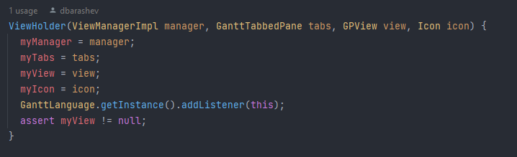**Command:** java/net/sourceforge/ganttproject/gui/view/ViewManagerImpl.java

ViewHolder has access to a ViewManager that is responsible to create and call classes to perform certain actions.

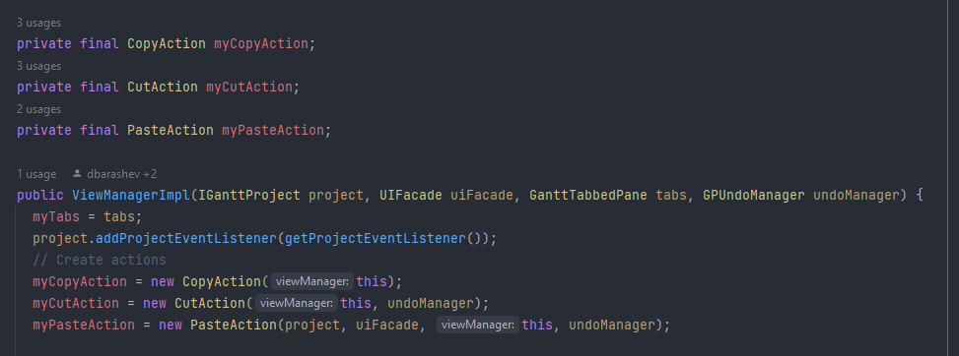

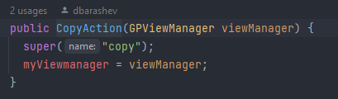

**Base Class (object creator):** ViewManager

**Created Classes (actions):**

* CopyAction
* CutAction
* 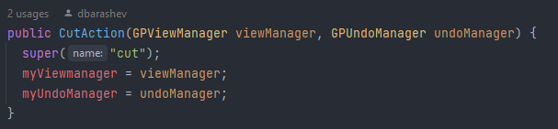PasteAction

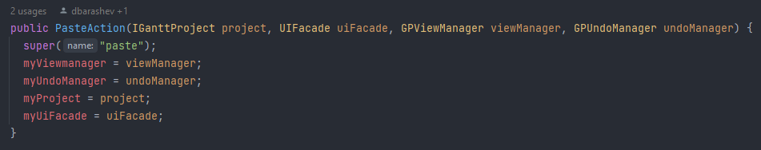

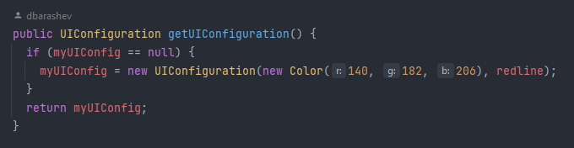**Singleton:** java/net/sourceforge/ganttproject/GanttOptions.java

Ensures that only one UIConfig is created for each GanttOption.

